SME

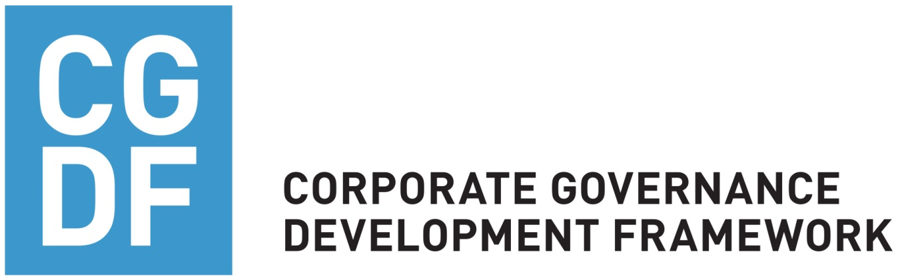

Worksheet

SME Governance Assessment Tool WORKSHEET
 | Question | Response/Comment | Recommendation
A1. | Commitment/Basic level
A1.1 | Are the basic formalities in place?  - Board of Directors  - Annual Shareholders’ Meeting  - Shareholders identified and recorded  - Charter or Articles of Incorporation
A1.2 | Is there a clear division of responsibilities and authorities between management and the Board?
A1.3 | Are the core functions in the company identified (accounting, legal, admin, IT)?
A1.4 | Does the company have documented strategic plans and budgets (1-3 years)?
A1.5 | Is developing governance structures somebody’s responsibility?
 | Question | Response/Comment | Recommendation
A2. | Commitment/Advanced level
A2.1 | Does the company have the following in place  - Code of Ethics  - Code of Conduct  - Written CG code  - Officer responsible for compliance  - Annual calendar of corporate events (Board meetings, Shareholders’ meetings)  - Terms of reference for key positions  - Core processes documented  - Does the (family owned) company have a succession plan
A2.2 | What steps has the company taken to improve its governance standards or practices?
A2.3 | Does the company have a Corporate Secretary?

 | Question | Response/Comment | Recommendation
B1 | Board and decision making /Basic level
B1.1 | - Are Board Meetings held according to a regular schedule?  - How many times per year did the Board meet (on average) during the last 2 years?  - Are the agenda and supporting material sent to board members well in advance?  - Who prepares the agenda for Board meetings?
B1.2 | Does the Board have the appropriate mix of skills?
B1.3 | Do the members of the Board understand what is their role and responsibilities?
B1.4 | Does the Board discuss the long term strategy of the company and the major material risks?
B1.5 | How are the Board members chosen? Is the director nomination based on some set of eligibility requirements?
B1.6 | - Are adequate minutes of Board and committee meetings prepared?  - By whom?  - How are decisions communicated to shareholders?  - Are the Board minutes distributed to Board members in a timely manner?
 | Question | Response/Comment | Recommendation
B2 | Board and decision making/Advanced level
B2.1 | - Is there a mandatory rotation of Board members?  - Have there been changes in the composition of the Board in the last 3 years?
B2.2 | Do Board members receive an induction and regular training?
B2.3 | Does the company have an established succession plan for the CEO and key positions?
B2.4 | Does the Board discuss, on an annual basis, its performance as a team?
C1 | Control Environment and Processes / Basic level
C1.1 | Do the head of internal audit (in-house or outsourced) and the independent external auditors report directly to the Board (or the audit committee, if created)?
C1.2 | Are there aspects of the company’s business that call for special attention to the control environment, including risk management (incl. IT security), internal controls, internal and external audit, and compliance (including environmental and other regulatory)?
C1.3 | Does the company provide information to the investors about how the risks are identified and managed?
C1.4 | Are the internal controls and auditing system periodically reviewed by the independent external auditors?

 | Question | Response/Comment | Recommendation
C1.5 | - Do the external auditors prepare an annual “management letter” with observations and suggestions regarding areas for improvements in the company’s accounting and controls?  - Is such document shared with the Board (or the audit committee, if established)?
C1.6 | Are there policies in place governing how the audit firm is selected?
D1 | Transparency and Disclosure / Basic level
D1.1 | Are adequate accounting and auditing systems in place?
D1.2 | Are semi-annual financial reports prepared by internal accounting? Who receives them?
D1.3 | - Are (annual) financial statements audited by an external audit company?  - Are they approved by Annual Shareholder’s Meeting?
D1.4 | Are financial statements prepared and disseminated to the shareholders in a timely manner?
D1.5 | - Are financial statements prepared in accordance with a widely accepted, internationally recognised system of accounting (IFRS or US GAAP)?  - For how many years have they been prepared as such?  - Was there a recent change in accounting policies?

 | Question | Response/Comment | Recommendation
D1.6 | Does the company comply with all local (including non-financial) disclosure requirements including yearly remits/licenses?
D1.7 | Are shareholders provided with information upon their request?
D2 | Transparency and Disclosure / Advanced level
D2.1 | Is the audit performed by an independent and respected firm?
D2.2 | Did the audit of annual financial statements give a qualified opinion?
D2.3 | For how many years has the company had the same audit firm?  Do accounting policies contain a periodic audit firm rotation requirement?  Has there been a change in audit firm not brought about by company audit rotation requirement?
D2.4 | Does the company provide a management discussion letter to shareholders and lenders, discussing forward looking issues (e.g., risks/opportunities, CSR practices) and a discussion letter analysing financial results and performance for the previous period?
D2.5 | Does the company disclose related party transactions (transactions with its shareholders/shareholder owned companies or its own subsidiaries/affiliates)?
D2.6 | Does the company have confidentiality policies in place concerning management and business information?

 | Question | Response/Comment | Recommendation
D2.7 | Is governance related information provided on the website?
E1 | Shareholders’ role / Basic Level
E1.1 | Is ultimate beneficial ownership disclosed?
E1.2 | Is there a shareholders agreement (SHA) in place?
E1.3 | Are there any arrangements (among the shareholders/family/directors/ lenders) that generate a disproportion between ultimate beneficial ownership and voting/control rights?
E1.4 | Is it expected that one or more of the equity partners will also be lenders to the company?
E1.5 | Are there any special rights of lenders?
E1.6 | Who has the power to call for a shareholders meeting?
E1.7 | Does the company convene/plan to convene shareholder meetings with agenda and explanatory material provided sufficiently in advance for adequate consideration by shareholders?
E1.8 | What is the frequency of shareholder meetings?
E2 | Shareholders’ role / Advanced Level
E2.1 | Are all shares of the same class treated equally?
 | Question | Response/Comment | Recommendation
E2.2 | Are there any tag-along and/or drag along rights?
E2.3 | Are Shareholders meetings well-organized and do they function effectively to allow for adequate shareholder participation in key governance decisions of the company?
E2.4 | In the period between the shareholders meetings, are all shareholders/lenders kept abreast of company policy, strategy, and results?
E2.5 | Does the company have a mechanism for dispute resolution?
E2.6 | Does the company have a formal dividend policy? If not, how are dividends determined and paid?
E3 | Family Governance (if applicable)
E3.1 | Has the family company developed key family governance policies like family employment, dividend policy and a family protocol (constitution)?
E3.2 | How are/ will the policies mentioned above be communicated to family members and others?
E3.3 | How can family members convey their ideas to the promoters and company governing bodies?
E3.4 | Has the family succession plan been developed and adopted?

Attachment: Board of directors’ composition

Name/gender  (Mr., Ms.) | Age | Year of first appointment | Tenure in the board | Type:  ID, NED, ED, ND | Shareholder, family member, close friend? (FM/CF/SH) | Role in the Board  (Ch/M) | Years of association with the company/  group | Experience (industry) | Background | Committee membership  (Name, Role – Ch/M) | Remuneration

Abbreviations:

ED – Executive Director. Executive directors carry out executive functions in the company (they are usually employees of the company).
NED – Non-Executive Director. Non-executive directors are not employees of the company and normally do not have the same involvement in the company’s day-to-day affairs as executive directors.
ID – Independent Director. Independent directors are non-executive directors that meet criteria of independence. Each jurisdiction might have its own definition of independence, but there are also internationally accepted (more stringent) definitions (see below IFC indicative definition).
ND – Nominee Director. Non-executive directors who are appointed under an arrangement or understanding with a major shareholder, a class of shareholders, a major creditor or some other group of people.
FM – Family Member
CF – Close Friend
SH – Shareholder
Ch – Chairperson
M – Member

Indicative Independent Director Definition:

"Independent Director" means a director who is a person who:
- has not been employed by the Company or its Related Parties in the past five years;
- is not, and is not affiliated with a company that is an advisor or consultant to the Company or its Related Parties;
- is not affiliated with a significant customer or supplier of the Company or its Related Parties;
- has no personal service contracts with the Company, its Related Parties, or its senior management;
- is not affiliated with a non-profit organization that receives significant funding from the Company or its Related Parties;
- is not employed as an executive of another company where any of the Company's executives serve on that company's board of directors;
- is not a member of the immediate family of an individual who is, or has been during the past five years, employed by the Company or its Related Parties as an executive officer;
- is not, nor in the past five years has been, affiliated with or employed by a present or former auditor of the Company or of a Related Party; or
- is not a controlling person of the Company (or member of a group of individuals and/or entities that collectively exercise effective control over the Company) or such person’s brother, sister, parent, grandparent, child, cousin, aunt, uncle, nephew or niece or a spouse, widow, in-law, heir, legatee and successor of any of the foregoing (or any trust or similar arrangement of which any such persons or a combination thereof are the sole beneficiaries) or the executor, administrator or personal representative of any Person described in this sub-paragraph who is deceased or legally incompetent, and for the purposes of this definition, a person shall be deemed to be "affiliated" with a party if such person (i) has a direct or indirect ownership interest in; or (ii) is employed by such party; “Related Party” shall mean, with respect to the Company, any person or entity that controls, is controlled by or is under common control with the Company.

http://cgdevelopmentframework.com/
Code of Ethics governs decision-making by setting out the values and principles of the company, e.g. investing in “green” practices.
Code of Conduct provides a more practical set of expectations for the employees by setting out specific behaviours that are required or prohibited, e.g. banning discrimination based on gender, age or race
For the purpose of this document: a number of years the person stayed connected to the company or a group by being an employee, director, consultant, advisor etc.
Please explain the structure of the remuneration. It could be: sitting fee, monthly payment, annual payment, commission, other.

