At a Glance: Climate Governance
Why Climate Governance?
Increasingly, investors expect companies to integrate climate risks into business strategy, culture and values. This has led to an emphasis on governance, risk management, and reporting – recommending that companies use climate scenario analysis to describe the potential impact of different possible outcomes on the organization’s performance, strategy and financial planning.
Simultaneously, several international initiatives guide companies in navigating regulations, standards and frameworks, and help them understand how to communicate and disclose risks and opportunities associated with climate change (e.g., Task Force on Climate-related Financial Disclosures (TCFD), CDP (previously known as the Carbon Disclosure Project), Principles for Responsible Investment and the IFRS Sustainability Standards Board forthcoming IFRS S2 Climate-related Disclosures).
In light of these developments, the need for corporate governance frameworks to assist companies in tackling climate change has emerged as a precondition to implementing company-level climate actions. As a central pillar of climate (corporate) governance, there is an expectation of having ‘climate competent’ boards who will understand not only the challenges that climate change presents but also the opportunities as transition plans become requirements, driven by the 'Race to Zero' launched at COP26 in 2021.
What is IFC’s Approach to Climate Governance?
IFC’s climate governance approach is a set of activities and tools supporting the WBG 2021-2025 Climate Change Action Plan, specifically contributing to the goal of mobilizing and catalyzing private capital and IFC’s climate agenda. It focuses on creating company-level governance structures and processes needed for climate risk management and adaptation. IFC has used its Corporate Governance Methodology to develop a framework and advice that focus specifically on climate.

What is the connection to IFC? Why does it matter?
This approach is to support efforts in assessing risk and building resilience of IFC’s clients, improving transparency standards and Paris Agreement alignment capacity, and contributing to market creation and mobilization by preparing prospective clients for development of climate strategies, risk frameworks and disclosure. It is also an IFC value-add product for mobilization and concessional financing partnerships, where IFC can build on its ESG trendsetter role and provide additional advice and roadmaps on climate governance.
Milestones
- In 2022, IFC developed the methodology (Climate Governance Matrix), training materials and auxiliary tools as a basis for the offering. The tools have been tested with ESG Advisory Program partner institutions from Europe and Central Asia, and with one bank from India.
- In 2023, following successful proof of concept, IFC will be integrating this offering into its ESG advisory and upstream toolbox, training staff to deliver the offering and engage in core activities (see below).
Key publications
- IFC Climate Governance Matrix (finalized and to be published by March 2023)
- IFC External Tip Sheet on Climate Governance (to be published in March 2023)
What are IFC’s Climate Governance core activities?
Activities aim at: providing stakeholders at large with knowledge and guidance on climate governance; climate risks mitigation in IFC’s own portfolio; support for clients in adopting and implementing climate governance frameworks and guidance for regulators; and building the capacity of standard setters and market intermediaries to steer markets towards good climate governance practices.
Through partnerships with climate stakeholders, IFC will contribute with its climate governance approach to ongoing efforts by working with investors, organizations and platforms active in climate action.
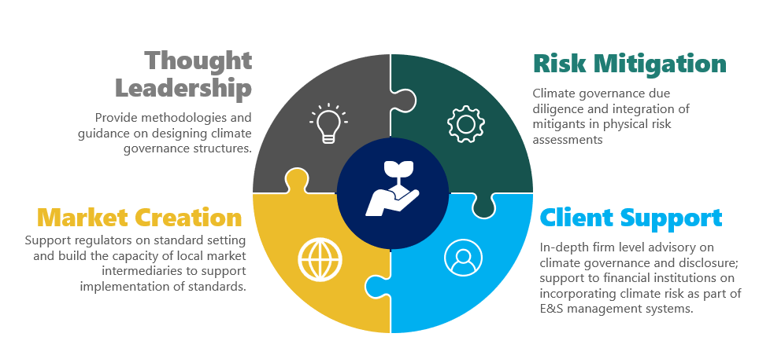
- Standard setting and thought leadership: building on its ESG leadership role, IFC will promote the recently developed climate governance matrix which assesses climate governance at the company level, starting from basic to international best practice. The matrix can be used by investors and companies to assess company-level climate governance risk or as a roadmap to improve climate governance practices. IFC will also develop thought leadership products to equip clients, investors and partners in furthering the climate governance agenda and will be integrating climate into its existing corporate governance tools.
- Risk mitigation: IFC will routinely incorporate climate governance mitigants in the IFC physical risk assessments (a joint effort by the Climate Business (CDB) and Sustainability and Gender Solutions (CEG) departments) and recommendations, and include climate governance in corporate governance due diligence for high climate risk projects. Climate governance diligence will complement the E&S risk assessment as an ancillary tool used to increase client capacity for managing climate risks and capturing the climate solutions upside.
- Client support will include in-depth advisory services on creating a climate governance framework, controls and compliance; conducting sustainability/climate reporting; and setting up climate risk screening for financial institutions. IFC will train boards and senior management on adopting a climate governance framework and overseeing the climate risks of their operations.
- Market creation: to level the playing field and accelerate the adoption of climate governance, IFC will provide advice to financial regulators, exchanges and industry associations on promulgating guidance, codes and regulations on climate governance and reporting. It will build the capacity of local market intermediaries (ESG training and consulting organizations) to offer climate governance training and services. This work will also build on the award-winning Beyond the Balance Sheet: Disclosure and Transparency Toolkit with advice on climate risk reporting and broader disclosure issues.

See https://www.fsb-tcfd.org/, https://www.cdp.net/en/, https://www.unpri.org/ and https://www.ifrs.org/content/dam/ifrs/project/climate-related-disclosures/issb-exposure-draft-2022-2-climate-related-disclosures.pdf

